Sampling handbook for the 2012 Accident and Emergency Department (A&E) Survey

The Co-ordination Centre for the

NHS PAtient survey programme



Last updated: 18th April 2012
Contacts

The Co-ordination Centre for the Patient Survey Programme
Buxton Court
3 West Way
Oxford
OX2 0JB

Tel: 01865 208127
Fax: 01865 208101
E-mail: emergency.data@pickereurope.ac.uk
Website: www.nhssurveys.org

Key personnel

Chris Graham (Manager)

Grace Baker
Esther Howell
Caroline Killpack
Jenny King
Katherine Körner
Sheena MacCormick
Catherine Turney
Mark Waters

Adherence to the procedures outlined in this document

It is not permissible to deviate from the agreed protocol as set out in this guidance manual, for example, by offering financial inducements or lottery prizes to respondents. Similarly, we do not recommend translation of questionnaires into other languages within the national survey. More guidance on how to reach ethnic minority groups can be found in Section 3 of the guidance manual. The terms of the ethical approval do not permit these types of alteration. Furthermore, such alterations might mean that the comparability of the survey would be compromised, and such results may not be acceptable for computation of the relevant measures within the Care Quality Commission assessments for that trust. If trusts want to make any adjustments to the method or materials set out in this guidance, they will need to seek local research ethics approval, and check with the Co-ordination Centre that the proposed alteration would not compromise comparability.

Updates

Before you start work on your survey, check that you have the latest version of this document, as there might be some small amendments from time to time (the date of the last update is on the front page). In the very unlikely event that there are any major changes, we will e-mail all trust contacts and contractors directly to inform them of the change.

This document is available from the Co-ordination Centre website at:

www.NHSSurveys.org

Contents
1. About this handbook 4
2. Compiling a list of patients 5
3. Final sampling inspection by the Co-ordination Centre 30

- About this handbook
This handbook is produced by the Co-ordination Centre for the Patient Survey Programme, on behalf of the Care Quality Commission.

This handbook is comprised of excerpts from the Guidance Manual for the 2012 Accident and Emergency Department (A&E) Survey and is intended to assist in the sampling for the survey. This abridged handbook is aimed at those carrying out the sampling for, but not directly coordinating or managing, the 2012 A&E Survey at each trust. Those who are co-ordinating the survey for the trust are strongly recommended to read the full guidance manual, with special attention to Section 3 - What’s new for 2012?.

Important

Please ensure that all sample lists are submitted to the Co-ordination Centre between 16th April and 18th May 2012 (we would appreciate if sample lists are submitted as early as possible to allow for any queries which may arise).

An anonymised sample file should be submitted to the Co-ordination Centre prior to the first mailing. If you are using a contractor, your sample should be submitted to this contractor, who will forward it to the Co-ordination Centre.

Please ensure that your sample list contains no patient name or address information. The sample file submitted to the Co-ordination Centre does not need to be encrypted.

If your trust is conducting the survey in-house, please send your sample file to emergency.data@pickereurope.ac.uk

If your trust is using a contractor, please submit your sample file to your contractor, who will then forward it to the Co-ordination Centre.

- Compiling a list of patients
This section explains how to draw a sample of patients. This task will need to be carried out by a member of staff at the NHS Trust. In hospital trusts, the sample will normally be drawn from the Patient Administration System (PAS). Prior to sending out questionnaires, the list will also have to be checked by the Demographics Batch Service (DBS) to identify deceased patients.

Please follow the instructions below carefully and allocate sufficient work time to check the sample with DBS before the first mailing and within the trust prior to each mailing.

We strongly advise that you read all of this section BEFORE you start to compile your patient list. It is imperative that you use the provided templates for each stage of the process- this will make it easier for you to draw the sample, and the correct number of records.

Compile a full list of patient attendances in 1 month

- Select the month of A&E Department attendances that your survey will cover. This should be January OR February OR March 2012.
Note:
If you decide to sample attendances in March 2012, we strongly recommend that you wait until the week commencing 16th April BEFORE you draw your sample to avoid having to remove a large number of patients from your sample because they are current inpatients (i.e. patients who were admitted to hospital following their attendance at the A&E Department).

- Compile a full list of all patient attendances at all Accident and Emergency Departments at all sites in your trust during one month.
- This is a list of attendances/visits, rather than a list of patients, so some patients will appear in the list more than once, but that does not matter at this stage.

The information you obtain about each patient will be used both for administering the survey and for sending to the tracing service to check for deceased patients. It saves time and effort if all the information is gathered at the same time.

The list should include:

ALL eligible adult patients, who have attended a major Accident and Emergency Department(s) within the trust for the chosen ‘sampling month’ (i.e. January or February or March 2012)

The list should exclude:

- Deceased patients;

- Children or young persons aged under 16 years at the date of their attendance at the A&E Department;

- Any attendances at Minor Injuries Units or Walk-in Centres;

- Any patients who were admitted to hospital via Medical or Surgical Admissions Units and therefore have not visited the A&E Department;

- Any patients who are known to be current inpatients;

- Planned attendances at outpatient clinics which are run within the A&E Department (such as fracture clinics);

- Patients attending primarily to obtain contraception (eg the morning after pill), patients who suffered a miscarriage or another form of abortive pregnancy outcome whilst at the hospital, and patients with a concealed pregnancy;

- Patients without a UK postal address (but do not exclude if addresses are incomplete but useable e.g. no postcode);

- Any patient known to have requested their details are not used for any purpose other than their clinical care (if this is collected by your trust you should ensure that you remove those patients from your sample list at this stage).

Data fields to include in the list of attendances
Please note: not all these fields are required by DBS but it will save time and effort if all the information is gathered at the same time.
You will need to keep the list in an electronic file in a programme such as Microsoft Excel or Access. The list should contain the following information:
- Title (Mr, Mrs, Ms, etc.)
- Initials (or First name)
- Surname
- Address Fields
- Postcode
- Year of birth
- Gender
- Ethnic category
- Day of attendance
- Month of attendance
- Year of attendance
- Time of attendance
- PCT of residence
- NHS site code
- GMPC code

Stage 1: Creating a sample of patients to send to the DBS
It is likely that your full list will include thousands of attendances, but you will need to send questionnaires to only 850 patients.
Note: You are aiming for a response rate of at least 50% (but many trusts will achieve a much higher response rate than that), which means that you should have about 425 completed questionnaires if you send questionnaires to 850 patients. You will be able to maximise your response rate by following this guidance carefully. It is not acceptable to try to boost the number of responses you receive by sending out questionnaires to a larger number of patients. The Co-ordination Centre will only be able to accept responses from the 850 patients in your list that have been correctly sampled. (See Section 10.12 for the accepted options for increasing your sample size)
The first stage is to take a systematic sample of patients to send to the DBS (Demographic Batch Service). It is likely that some of your patients will have died, so it is advisable to select an initial sample of 900 patients, which will later be reduced to 850.

To select the 900 patients for sending to DBS, you should follow the procedure below:

- Download the sample construction workbook for creating a DBS sample from the NHS surveys website (http://www.nhssurveys.org/survey/1143). The workbook is called ‘AE2012_Sampling construction workbook_900 FOR DBS_v1.0’.
- In the second worksheet called ‘Sample list (PRE DBS)’ put the list of all eligible attendances in your chosen month (i.e. January, February OR March 2012) into the appropriate columns in the sheet (starting from column C which is called Trust code).
Second worksheet: ‘Sample list (PRE DBS)’
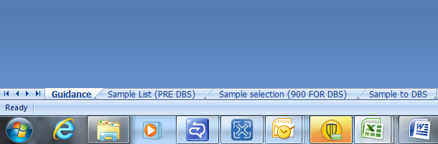
- Sort the list by the patient’s year of birth, gender and PCT of residence. (N.B. Ensure that you select all columns before sorting in Excel, otherwise the patient details will get mixed up). Sorting should ensure that all attendances by the same patients come next to each other in the list.

- Count the total number of attendances in the chosen month, and in column A which is called ‘Position in list’ and is highlighted blue, number each attendance in the list in ascending order (for example, if you had 2510 attendances, you would number from 1 through to 2510).
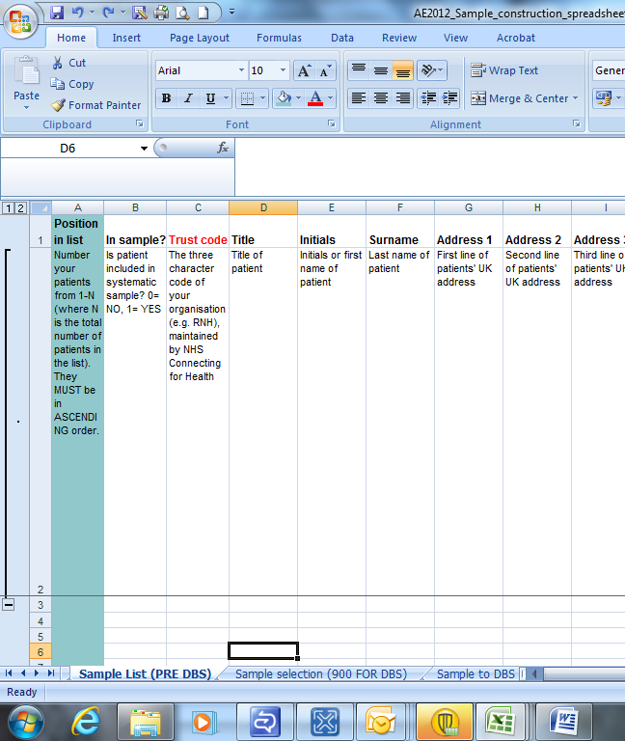
Number every attendance in your list in ASCENDING ORDER and enter in this column
- Once you have numbered every attendance, your sampling interval will have been automatically calculated for you (this can be found in the third worksheet called ‘Sample selection (900 for DBS)’).
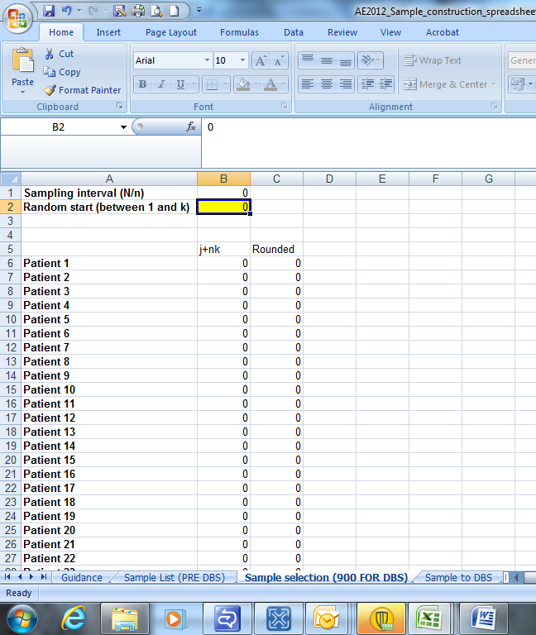
Sampling interval: This will be automatically calculated for you
- You need to decide what your random start is going to be: this must be a whole number between 1 and the value of your sampling interval.
- Go to the third worksheet called ‘Sample Selection (900 for DBS)’ and enter the random start into the yellow box. When you do this you may notice that some of the figures in this worksheet change- this is what is meant to happen and will be used to determine which records to select.

Enter random start in the yellow box

- Go back to the second worksheet called ‘Sample list (PRE DBS)’ and you will see that each record should have either a 0 or 1 in column B which is called ‘In sample?’. All records with a 1 in column B will be included in the DBS sample for your trust.

IT IS VITAL THAT YOU DO NOT CHANGE ANY OF THE VALUES IN COLUMN B- THIS MAY INTRODUCE SAMPLE BIAS WHICH MEANS THE SAMPLE WOULD NEED TO BE REDRAWN

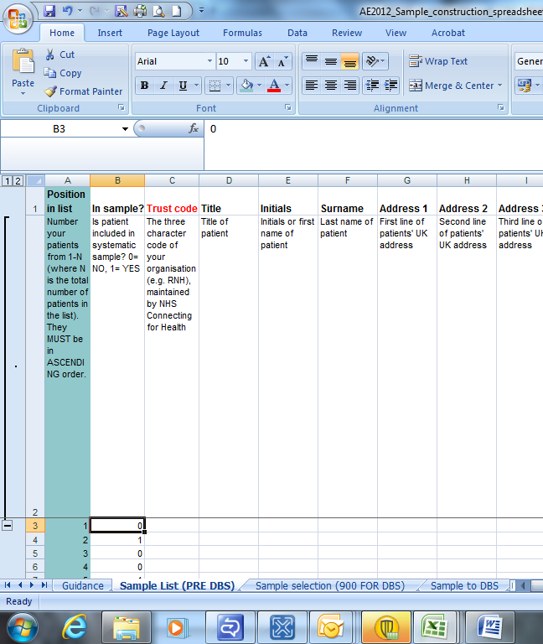
This column will either have a 0 or 1 in it:
1= record IS included in sample
0= record IS NOT included in sample

- Delete all records that DON’T have a value of 1 in column B.
- Select all the remaining records (with any required information for DBS) and copy across into the fourth worksheet called ‘Sample to DBS’. THIS IS THE INFORMATION THAT WILL BE SENT TO THE DBS FOR CHECKS.
- Note that if patient’s name appears more than once, remove any duplications so you only have one attendance per patient. COPY THIS WORKSHEET ACROSS INTO A SEPARATE WORKBOOK FOR SUBMISSION TO THE DBS (see below for creating a tracing file).

Fourth worksheet: ‘Sample to DBS’

Checks carried out by the trust

Once you have compiled your list of 900 patients, you should carry out the following checks before you send the list to the DBS to carry out a further check for deceased patients.

- Duplications. You should check your list to make sure patients’ names do not appear more than once, and you should remove any duplicated names.

- Current inpatients. Check that none of the patients are known to be current inpatients in your trust (or elsewhere, if possible)

- Patient ages. Check that all patients are aged 16 or over at the time of their attendance at the A&E Department

- Postal addresses. Exclude any addresses that are outside the UK

- Incomplete information. Check for any records with incomplete information on key fields (such as surname and address) and remove those patients. However, do not exclude anyone simply because you do not have a postcode for them. Only remove a patient if there is insufficient name or address information for the questionnaire to have a reasonable chance of being delivered. The more cases that are removed at this stage, the poorer the sample coverage and the greater the danger of bias

- Check that you have not included any patients who attended primarily to obtain contraception (eg the morning after pill), patients who suffered a miscarriage or another form of abortive pregnancy outcome whilst at the hospital, and patients with a concealed pregnancy.

- Any patient known to have requested their details are not used for any purpose other than their clinical care (if this is collected by your trust you should ensure that you remove those patients from your sample list at this stage).

- Deceased patients. Check hospital records do not have a record of a patient’s death from a subsequent attendance or visit to hospital
Checks for deceased patients

One of the most reliable and up-to-date sources of information on patient deaths is your own trust’s records. It is essential that you check that your trust has no record of a patient selected for the survey having died at your trust. Relatives are likely to be particularly upset if they receive a questionnaire or reminder from the trust where their relative died. Clearly, patients may also have died at home or while under the care of another trust, so you still need to check with the demographic batch service (DBS) as well.

The methodology for this survey requires three stages of checks for deceased patients before the first mailing is sent out. The checks are carried out sequentially by:

- the trust
- DBS
- again by the trust (for patients who may have died in hospital after submission of the sample to DBS)

You are also advised to repeat this check before the second and third mailings, and to ensure that approved contractors are advised immediately if any patients in the sample die during the survey period.

Submit the patient list to the Demographics Batch Service (DBS)

Before sending out the questionnaires, the list of patients should be checked for any deaths by the Demographics Batch Service (DBS).

The DBS enables users to submit and receive a file containing relevant patient records electronically using dedicated client software. The patient records in the file are matched against the NHS Spine Personal Demographics Service (PDS).

Create a trace request file

Using your list of patients, you need to create a correctly-formatted batch trace request file to send to DBS. You should take advice from your local Trust PAS team on the correct format to submit files. Technical details on the file format are available from:

http://www.connectingforhealth.nhs.uk/industry/docs/files/dbs/index.html

For each patient you will need to include as a minimum:
- NHS number and full date of birth (yyyymmdd) – this is the recommended approach OR
- Surname, first name, gender, date of birth and postcode (can be wildcarded eg LS1*)
Although residential postcode is not mandatory it is highly recommended to include it to avoid incorrect matches. Due to the way addresses are recorded throughout the NHS, it is very difficult to get an exact match on address lines. For this reason, do not include address lines in the trace request file.

Submitting the trace request file

Please note that the DBS does not accept the transfer of files by encrypted emails or on physical media. Instead, request and response files must be transferred electronically using the dedicated DBS client software. The DBS client software should have already been installed on a server within your trust. Please speak to a member of your IT department or PAS team if you do not know how to access and use the application. If your IT department cannot help, contact the DBS implementation team at: demographics@nhs.net and they should be able to advise you.

If you have been set up to use DBS, then once you have created the request file, it should be placed in the client in-box. The DBS client will then send the file to the Spine and, if you are registered, you will receive an email to say that the file was received. The DBS processes the file overnight and it should be ready the following morning. You will be notified by email when the file has been processed. During periods of high demand for DBS service, it may take 48 hours for your file to be returned.

The response file

The DBS will return a header row, response body and trailer row. The response row will be in two parts:
- The response containing all the data supplied in the request record, together with a trace outcome indicator. The main record is returned in all cases.
- An additional response column, which is returned only when there is a single unique match. It is on this additional response column that patients found to be deceased will be indicated.

Further information is available from www.cfh.nhs.uk/demographics/dbs
Note

Please be aware that tracing services are not foolproof and even after your patient list has been checked for deaths, some patients may die in the period between running the check and the questionnaire being delivered. You may find that some recently deceased patients remain in your sample. You need to be prepared for this. Special sensitivity is required when dealing with telephone calls from bereaved relatives.

Stage 2: When the patient file is returned from DBS

The trace response file returned from DBS can be used to identify any patients that have died (indicated by a letter ‘D’) and therefore need to be deleted from the sample file. This will reduce the numbers in your sample list slightly.

You should not exclude patients just because it was not possible for DBS to match them on their records. If you did this, you would bias the sample.

If you have more than 850 patients remaining on your list

When your patient list comes back from DBS and you have removed all deceased patients, there may still be more than 850 patients in the list. You will need to systematically sample again to reduce it to 850 records.

To do this you must follow the procedure outlined below:

- Download the sample construction workbook for creating your final sample from the NHS surveys website (http://www.nhssurveys.org/survey/1144). The workbook is called ‘AE2012_Sample construction workbook_FINAL 850 SAMPLE_v1.0’.
- In the second worksheet called ‘Sample list’ put the list of all eligible cases from the DBS returned file.
- Count the total number of records, and in column A called ‘Position in list’ and highlighted blue, number each record in the list in ascending order (for example: from 1 to 872 if you had 872 records).

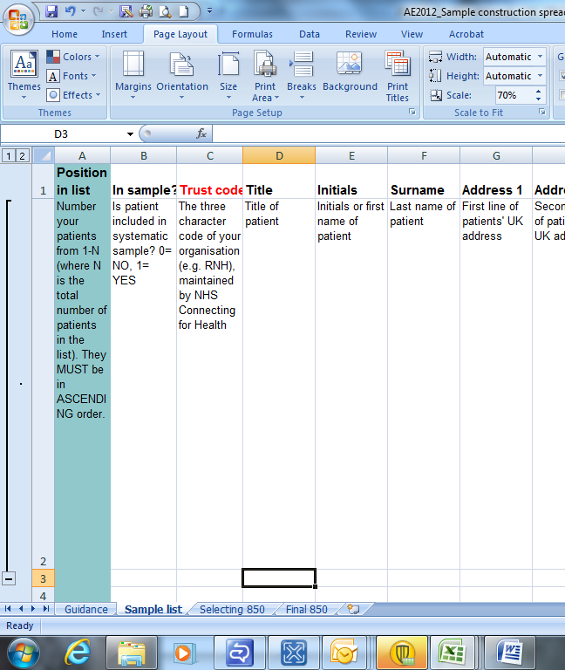
Number every record in your list in ASCENDING ORDER and enter in this column

- Once you have numbered every record, your sampling interval will have been automatically calculated for you and will be shown in the third worksheet called ‘Selecting 850’.

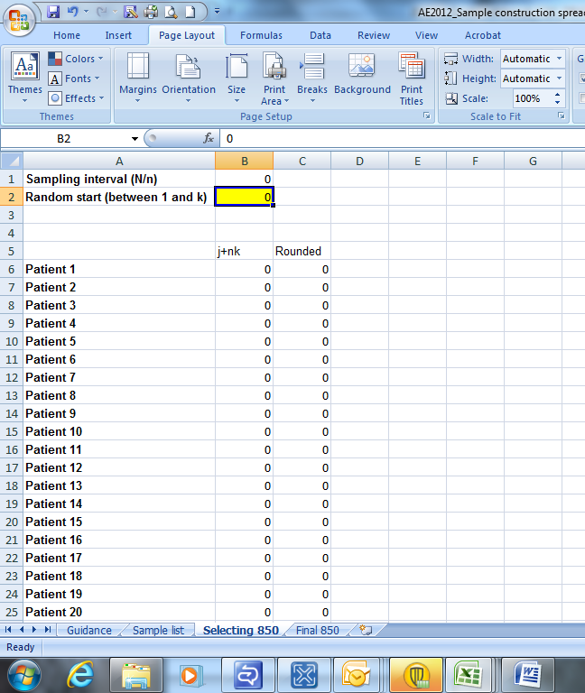
Sampling interval: this will be automatically calculated
- You need to decide what your random start is going to be: this must be a whole number between 1 and the value of your sampling interval.
- Go to the third worksheet called ‘Selecting 850’ and enter the random start into the yellow box- the other numbers on this worksheet will change, but this is meant to happen and should be left as is.
Random start: enter in the yellow box
- Once you have done this, go back to the second worksheet called ‘Sample list’ and you will see that each record should have either a 0 or 1 in column B which is called ‘In sample?’. All records with a 1 in column B will be included in the final sample for your trust.

IT IS VITAL THAT YOU DO NOT CHANGE ANY OF THE VALUES IN COLUMN B- THIS MAY INTRODUCE SAMPLE BIAS WHICH MEANS THE SAMPLE WOULD NEED TO BE REDRAWN

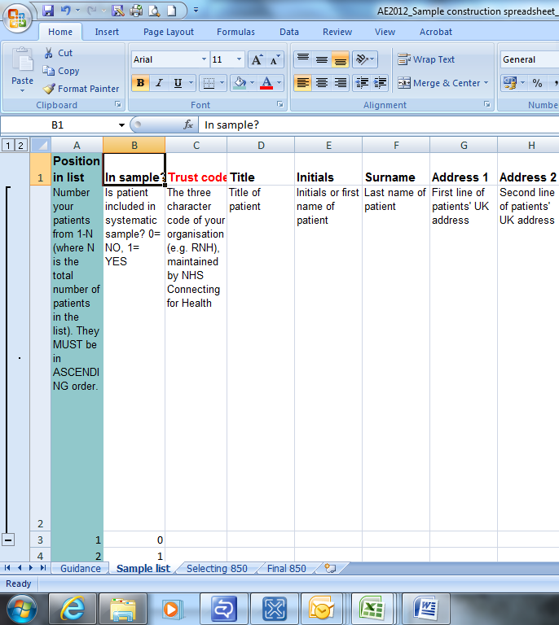
This column will either have a 0 or 1 in it:
1= record IS included in sample
0= record IS NOT included in sample
- Delete all records that DON’T have a value of 1 in column B.
- Select all the remaining records (along with corresponding information) and copy across into the fourth worksheet called ‘Final 850’. THIS IS THE INFORMATION THAT WILL BE SENT TO THE CO-ORDINATION CENTRE FOR CHECKING.
- Before sending your final sample file to the Co-ordination Centre, make sure you remove the patient identifiable data and that every record in` the file has a patient record number (format AE12NNNXXXX where NNN= your trustcode and XXXX=0001-0850)
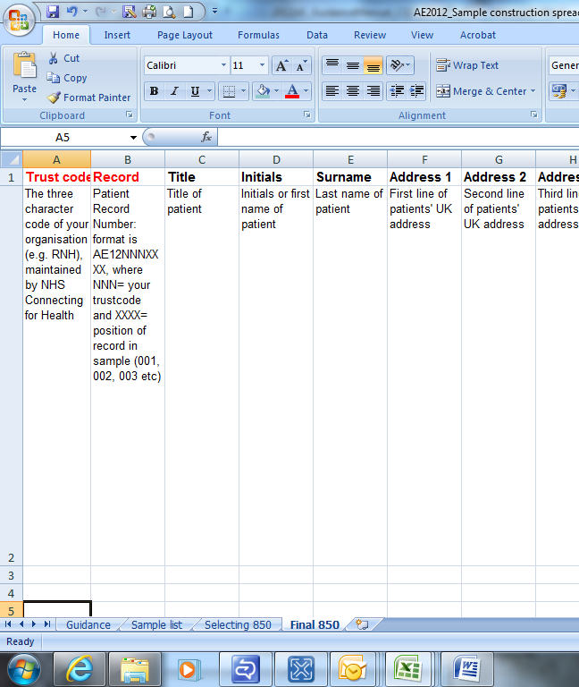
Patient record number: unique number for each patient

If you have fewer than 850 patients remaining on your list

If your patient list has fewer than 850 patients after deceased patients have been removed, you MUST contact the Co-ordination Centre on 01865 208127 or email emergency.data@pickereurope.ac.uk.

Important note

You are aiming for a response rate of at least 50%, which means that you should have about 425 completed questionnaires if you send questionnaires to 850 patients. You will be able to maximise your response rate by following this guidance carefully, drawing your sample and mailing out as soon as possible, and you will need to send out two reminders. It is not acceptable to try to boost the number of responses you receive by including more patients when compiling the sample of 850 for the survey as this would bias the survey. The Co-ordination Centre will only be able to accept responses from the patients in your list of 850 that have been correctly sampled and mailed. (See section 10.12 for the accepted options for increasing your sample size)

Create the sample file

An example of the final sample worksheet you should complete has been included below. This worksheet is called ‘Final 850’ and is found in the ‘AE2012_Sample construction workbook_FINAL 850 SAMPLE.xls’ (see section 10.5).

This worksheet has three purposes:

- It will be used to keep a record of which patients have not returned questionnaires so that reminders can be sent to them.
- It will be used to generate weekly response rates for your trust that must be forwarded to the Co-ordination Centre every Thursday from the 10th May 2012 until the closing date of the survey.
- The anonymous data in this file (i.e. all the data except patient name and address information) will form part of the file that you will submit to the Co-ordination Centre when the survey is completed.

Table 1 – Sample Excel file of patient details
NHS Trust Code | Patient record number | Title | Initials | Surname | Address1 |  | Address5 | Postcode | Year of birth | Gender | Ethnic category | Day of attendance | Month of attendance | Year of attendance | Time of attendance | PCT of Residence | NHS Site code | GMPC | Day of questionnaire being received | Month of questionnaire being received | Year of questionnaire being received | Outcome | Comments
R1X | AE12RX10001 | Mrs | AM | Abbot |  | -- |  | AB1 1YZ | 1934 | 2 | A | 5 | 3 | 2012 | 10:30 | 5LS | RR115 | A12345 |  |  |  | 3 | Informed that patient had died
RQA | AE12RQA0002 | Mr | EC | Ahmed |  | -- |  | AB2 6XZ | 1970 | 1 | J | 20 | 3 | 2012 | 13.45 | 5LT | RTE03 | B12345 | 04 | 05 | 2012 | 1
 |  |  |  |  |  | --
RZZ | AE12RZZ0849 | Ms | K | Yoo |  | -- |  | AB4 7MX | 1950 | 2 | R | 17 | 3 | 2012 | 11.10 | 5LS | RR115 | F56789
RLF | AE12RLF0850 | Ms | F | Young |  | -- |  | AB9 5ZX | 1946 | 2 | A | 14 | 3 | 2012 | 23.55 | 5GT | RR117 | G56789 | 16 | 06 | 2012 | 1

Important note about table 1

The headings of Table 1 are in three different colours:
Bold black headings: these columns contain information on patients’ names, addresses and comments that may allow them to be identified. This information should be deleted from all files sent to the Co-ordination Centre
Red italic headings: these columns should be completed during the sampling phase and submitted to the Co-ordination Centre prior to mailing for final inspection (see Section Error: Reference source not found) and at the conclusion of the survey
Green italic headings: these columns should be completed when the patient responds to the survey, either by returning a completed questionnaire, or the trust has been notified that the patient will not be participating (patient deceased, moved address, too ill, or called to opt out).
The following information is compiled using hospital records:

- NHS Trust Code
- Patient record number. Please use the following format: AE12NNNXXXX where NNN is your trusts 3 digit trust code and XXXX is the 4 digit number relating to your sampled patients, e.g., 0001-0850.The patient record number will be included on address labels and on questionnaires. Later, when questionnaires are returned (whether completed or not), you (or the approved contractor) will be able to use these numbers to monitor which patients have returned their questionnaires and to identify any non-responders, who will need to be sent reminders. If an approved contractor is used, you will need to agree with them on the range of serial numbers that will be used for your patients.
- Title (Mr, Mrs, Ms, etc.)
- Initials (or First name)
- Surname
- Address Fields
- Postcode
Note

The Patient Record Number, Title, Initials, Surname, Address fields and Postcode are used for printing out address labels. You (or your contractor) can use the mail merge function in a word processing package for this purpose.
- The Year of Birth should be included in the form of NNNN.
- Gender should be coded as 1 = male and 2 = female.
- Ethnic Category. The ethnicity of a person is specified by that person, and should be coded using the 17 item alphabetical coding specified by NHS Connecting for Health. The codes are as follows:
National Codes:
White
A British
B Irish
C Any other White background

Mixed
D White and Black Caribbean
E White and Black African
F White and Asian
G Any other mixed background

Asian or Asian British
H Indian
J Pakistani
K Bangladeshi
L Any other Asian background

Black or Black British
M Caribbean
N African
P Any other Black background

Other Ethnic Groups
R Chinese
S Any other ethnic group

Z Not stated

It is acknowledged that patient records might not always contain complete data on patients' ethnic category. However, this field should be included wherever possible. This data is required in order to evaluate non-response from different ethnic categories. This is in keeping with the aims of the Care Quality Commission and Department of Health to be more responsive to all ethnic groups and provide services that take account of their individual requirements.

- Day of the month of attendance (1 or 2 digits; eg 7 or 26)*
- Month of attendance (1 or 2 digits; eg 02 or 3) *
- Year of attendance (4 digits; eg 2012) *
- Time of attendance (4 digits in 24-hour format; HH:MM e.g. 09:25, 23:15)
- PCT of Residence should be coded using the first three characters of the PCT character codes (maintained by the National Administrative Codes Service). They provide postcode files which link postcodes to the PCTs
- Hospital Site Code: This is a new inclusion for the 2012 survey. Please use this space to record the site at which the patient was seen using the five character NHS Trust Site Codes (maintained by Connecting for Health).
http://www.connectingforhealth.nhs.uk/systemsandservices/data/ods/datafiles
- General Medical Practice Code (GMPC): This is a new inclusion for the 2012 survey. Please record the six character organisation code of the GP practice at which the patient is registered. http://www.connectingforhealth.nhs.uk/systemsandservices/data/ods/datafiles

Additional information should also be entered on this spreadsheet. The details of this information are discussed below:

- Day of questionnaire being received. This can only be completed if and when a questionnaire is received by the trust or approved contractor. It should be a one or two digit numerical response not a date format, eg. N or NN not 12/05/12.
- Month of questionnaire being received. This can only be completed if and when a questionnaire is received by the trusts or approved contractor. It should be a one or two digit numerical response, not a date format.
- Year of questionnaire being received. This can only be completed if and when a questionnaire is received by the trusts or approved contractor. It should be a four digit numerical response, not a date format.
- The Outcome field will be used to record which questionnaires are returned to the freepost address, or are returned undelivered, or which patients opt out of the survey, etc.
1 = Returned useable questionnaire
2 = Returned undelivered by the mail service or patient moved house
3 = Patient died
4 = Patient reported too ill to complete questionnaire, opted out or returned blank questionnaire
5 = Patient was not eligible to fill in questionnaire
6 = Questionnaire not returned (reason not known).
The outcome column is left blank at first if the survey has not been returned (on Table 1 you can see that Ms Yoo has not yet returned her questionnaire).
- The Comments column is useful for recording any additional information that may be provided when someone calls the helpline – for example, to inform you that the respondent has died or is no longer living at this address.

Distribution of patient ages

You should check that patients of all ages are included in your sample, especially those aged 16, 17,18 or over 75 years. We have found these age groups are the most likely to be excluded due to poor sampling. It is possible there may not be any young adults or very old adults in your sample, but this should be confirmed by checking your original sample (before exclusion criteria were applied) and your sampling techniques.

Check that your sampled patients’ ages cover the full range of expected ages. Ideally, you should do this by checking the distribution of ages on a histogram (See Figure 1). For most trusts the histogram should generally decrease with age, (representing higher numbers of younger adults) then increase slightly for those aged around 60 years (baby-boomers), before entering a further decline to reflect fewer people at extreme old age.

Figure 1 - Age Histogram for 2008 A&E Survey sample information

Distribution of patient gender

Your sample will probably have similar proportions of men and women- unless your trust treats men or women only. You should check both of these genders are included and that you can explain if the sample is skewed toward male or female patients.

Check for other sample errors

The most common sampling errors made in the 2008 survey resulted from trusts:

- Including patients aged under 16
- Excluding patients aged 16
- Excluded patients born before a particular year (1930)
- Incorrect PCT coding
- Incorrect ethnicity coding
- Missing year of birth data
- Incorrect age distribution due to incorrectly following the guidance

Using the guidance correctly will prevent any errors and may reduce delays caused by mis- sampling, consequentially improve your response rate to the survey.

Separating mailing details from sample information

At this point you should transfer the names, address and postcode for each patient in the sample to a new file. The patient record number (PRN) for each patient should be copied to the new file, so that the two datasets are connected using the unique PRN. It is essential to ensure this number is correctly applied to the two datasets. Save this new file as “A&E2012_mailing data”.
This file should be used for mailing purposes: it will be used to check for deceased service users prior to reminder mailings and will be cross-referenced with the sample file (<NHStrustname>_A&E 2012) to identify service users who will need to be sent reminders.

As this “A&E2012_mailing data” file will only be used occasionally during the survey, we recommend you keep this file encrypted. The mailing data file should be destroyed when the survey is complete. This should be done by both the trust and the approved contractor, along with all other files created for the survey (aside from the survey response file).
For patient confidentiality reasons, it is essential that you do not keep patient name and address details in the same file as their survey response data.

Table 3 – Example mailing file
NHS Trust Code | Patient record number | Title | Initials | Surname | Address1 | Address2 | Address3 | Address4 | Address5 | Postcode
R1X | AE12R1X0001 | Mrs | AM | Abbot | 14 Station Road | London |  |  |  | AB1 1YZ
RQA | AE12RQA002 | Mr | EC | Ahmed | Flat 7 | Short Street | Oxford |  |  | AB2 6XZ
 |  |  |  |  |  | --
RZZ | AE12RZZ0849 | Ms | K | Yoo | The Maltings | Birch Road | Little Abington | Cambridge | Cambs | AB4 7MX
RLF | AE12RLF0850 | Ms | F | Young | 634 Tyne Road | Newcastle-Upon-Tyne | Tyne and Wear |  |  | AB9 5ZX

Sharing the patient sample file with an approved contractor

If you are working with an approved contractor and have a contract in place relating to the transfer of patient identifiable information (i.e. names and addresses) both the sample file (“<NHStrustname>_A&E2012”) and the mailing file (“A&E2012_mailing data”) file should be sent to the contractor staff in encrypted format (see Section 6.6 - Encryption of personal data).

If you are working with an approved contractor, but have chosen to mail out the questionnaires yourself, within the trust, you should supply them with just the sample file (this will resemble Table 1- Sample Excel file of patient details but with the patient names, addresses and postcodes removed). The contractor can use this list to record the outcome codes, but you should ensure that the contractor is kept up to date with any information that comes directly to the trust about patient deaths, etc.

Making more use of the survey locally

Up to this point, this section of the guidance has described in detail how sampling must be undertaken to provide the basic required sample of 850 patients for the national survey. In addition to this minimum requirement, though, your trust may wish to use the A&E survey as an opportunity to gather further data beyond that required by the Care Quality Commission. Increasing the sample size is a good way to do this.

Increasing the sample size for the survey may be helpful if, for example, you wish to:
- Analyse or compare results for specific subgroups (for example, patients treated at different sites or patients of different ethnicities) in more detail than would be possible from a sample of 850 patients. By increasing the sample size you can ensure that you have a large enough sample of patients from each group
- Cover a very wide range of questions without exceeding the maximum questionnaire length of 12 pages for the main survey. If you wish to ask a large number of questions from the question bank, it would be possible to use two different versions of the questionnaire with a different selection of questions included, each going to a separate sample (please note however that all patients in the core sample of 850 must receive an identical questionnaire which must include the core questions).
- Alternatively, if your trust regularly treats very large numbers of patients, you may wish to draw an extra sample of patients to survey additionally to those included in the main survey. For example, you could select patients discharged in a different time period from those in the national survey and send them questionnaires either at the same time as or at some point after the national survey. By running the survey locally in addition to the national survey, you can establish a more frequent pattern of reporting enabling you to track experience over time, or test the impact of recent quality improvement initiatives. If you decide to carry out an A&E survey locally at the same time as the national survey you
will need to ensure that you are sampling two distinct and separate groups of patients which do not overlap. Guidance for carrying out a local survey is available at: http://www.nhssurveys.org/localsurveys

If you are using an approved contractor for the survey then they will be able to advise you on the best way to increase your sample size to achieve your specific goals. If you are not using an approved contractor, then the coordination centre will be able to advise on any queries you might have via e-mail at advice@pickereurope.ac.uk or call 01865 208127. However, before you decide to do this, there are some important points to consider:

- Please note that the section 251 approval obtained for the 2012 A&E Survey only covers the transfer of patient information required for carrying out the Core survey. If you wish to collect any additional sample information you will need to seek advice from the National Information Governance Board as to whether further approval is needed. For further information please see: http://www.nigb.nhs.uk/
- The core sample for the 2012 A&E survey must be drawn as specified in this guide; any deviation from the guidance may make it impossible for the Care Quality Commission to use the data that you collect. It is therefore essential that any additional sample drawn can be easily distinguished from the core sample, and that it is drawn in such a way as to not interfere with selection of the core sample.
- If you are planning to undertake surveys more frequently than the national programme, then you should consider how any increased sample here will fit with the additional surveys you will be undertaking.

- Final sampling inspection by the Co-ordination Centre
Trust data should be checked for errors and received back from DBS before being forwarded to the Co-ordination Centre. An anonymised sample file must be submitted to the Co-ordination Centre prior to the first mailing. This is to allow us to make final quality control checks. All columns in red italics in Table 1 (Sample Excel file of patient details) must be submitted, but name, address and postcode details must be removed.

If you are using an approved contractor, the sample should be checked as normal by the trust and by DBS before being submitted to the contractor. We strongly recommend the contractor carries out the same high standard of checks as in previous years before submitting the file to the Co-ordination Centre. The Co-ordination Centre will address any issues arising from these final checks to the approved contractor.

The Co-ordination Centre will be checking for extraordinary errors. These are more visible when viewing data from many trusts at one time. For this reason, samples will be checked as collated files. Emails discussing any sample anomalies will be sent to the trust or approved contractor which provided them on Tuesday of each week. [Please note: samples submitted on a Monday must be sent to the Co-ordination Centre by 11am for the samples to be returned to the trust or approved contractor the following day.]
Making the most of the fieldwork period

Because certain demographic groups (specifically younger patients and those from black and minority ethnic categories) have been shown to take longer to respond to patient surveys, we strongly recommend that files are submitted within the four weeks specified for sample checking. The best way to ensure you can do this is to prepare before the start date of the survey (7th May 2012). You can do this by:
- Allocating sufficient time to the individual who will generate your sample to allow them to generate it, dispatch it to DBS, and to respond to queries or corrections specified by your contractor or the Co-ordination Centre
- Discussing the work with your Caldicott Guardian to ensure they are available to sign off any necessary documents for the survey
- Ensuring your trust is registered with DBS and that the person who submits your sample to them understands their requirements – problems with data submitted to tracing services is one of the most significant obstacles in mailing out your survey in good time. Also, do not assume you are registered – please check this ahead of time.
- Printing questionnaires and assembly of mailing packs before the sample is signed off. However, please ensure that the envelopes are left open so that you can check the correct label is applied to the correct questionnaire. This means that you should decide on your questions as early as possible so arrange the times for any meetings that will discuss the questionnaires as early as possible.

Your first mailing should take place as soon as possible after your sample has been approved by the Co-ordination Centre but must not be later than seven days after this. A large time lag increases the likelihood of patients having died between the sample file being received back from DBS and the questionnaire being received, increasing the risk of distress to family members and complaints to your trust.

For the 2012 A&E survey, the specified sample submission dates are:

Date sample received | Date sample returned
23/04/2012 – 30/04/2012 | 01/05/2012
01/05/2012- 04/05/2012 | 08/05/2012
08/05/2012-14/05/2012 | 15/05/2012
15/05/2012- 21/05/2012 | 22/05/2012

Samples should be submitted to the Co-ordination Centre by the 22nd May 2012 at the latest. If they do not, there is a risk your trust will not have enough time to correct any problems in the sample and complete the survey with an acceptable response rate. Major errors may then result in the data from the trust being excluded from the relevant Care Quality Commission assessments.

Trusts which have not submitted their sample for checking by the 22nd May 2012 will be contacted by the Co-ordination Centre to discuss any problems you are having and how we can help with the process. However, if samples are not received by the 29th May 2012, then we are required to notify the Care Quality Commission of this and they will contact you to discuss any implications for inclusion in Care Quality Commission produced data.

A major or consultant led 24 hour service with full resuscitation facilities and designated accommodation for the reception of accident and emergency patients
The PDS is a national electronic database of NHS patient demographic details. The PDS does not hold any clinical or sensitive data such as ethnicity or religion.
The address should be held as separate fields (eg. street, area, town and county), consistent with the address format required by the DBS.
These codes can be found in the NHS Data Dictionary provided by Connecting for Health on the following website: http://www.datadictionary.nhs.uk/data_dictionary/attributes/e/enh/ethnic_category_code_de.asp?shownav=1
The code “Z” should only be used if the patient was asked for their ethnic category but refused to provide it. If this code is missing for any other reason, ethnic category should be left blank in the sample information.
* Date fields must be supplied in separate columns (eg date, month, and year).
As shown in table 1(section 10.6), the ‘outcome’ field in the sample file is used to record which questionnaires are returned completed, or are returned undelivered, or which patients opt out etc.
See section 18 for more information on the reliability of data based on different numbers of respondents.
Created by removing the patients’ names, addresses and postcodes.

